**COMPREHESIVE SYSTEM FOR IDENTIFYINY**

**AND MITIGATING FAKE SOCIAL MEDIA**

**ACCOUNT**

**PROJECT REPORT**

***Submitted by***

|  |  |
| --- | --- |
| **RANJITH R** | **611521104086** |
| **TAMILSELVAN A D** | **611521104109** |
| **VASANTH S P** | **611521104113** |
| **VIGNESH J** | **611521104114** |

***in partial fulfillment for the award of the degree***

***of***

**BACHELOR OF ENGINEERING**

**IN**

**COMPUTER SCIENCE AND ENGINEERING**

**Department of Computer Science and Engineering**

**MAHENDRA INSTITUTE OF ENGINEERING AND TECHNOLOGY**

**Mahendhirapuri, Mallasamudram**

**Namakkal – 637503**

**MAY 2025**

**MAHENDRA INSTITUTE OF ENGINEERING AND TECHNOLOGY**

**Mahendhirapuri, Mallasamudram**

**Namakkal - 637503**

**Department of Computer Science and Engineering**

**BONAFIDE CERTIFICATE**

Certified that this project report **“COMPREHENSIVE SYSTEM FOR IDENTIFYING AND MITIGATION FAKE SOCIAL MEDIA ACCOUNT”** is the bonafide work of **“RANJITH R (611521104086),TAMILSELVAN A D (611521104109),VASANTH.S.P(611521104113),VIGNESH J (611521104114)”** who carried out the project work under my supervision.

|  |  |
| --- | --- |
| **SIGNATURE** | **SIGNATURE** |
| **Dr.U.NILABARNISHA,M.E,M.B.A,Ph.D.,** | **Mrs.P.BANUPPRIYA, M.E.,** |
| **HEAD OF THE DEPARTMENT** | **SUPERVISOR** |
| Associate Professor | Assistant Professor |
| Department of Computer Science and Engineering | Department of Computer Science and Engineering |
| Mahendra Institute of Engineering and Technology | Mahendra Institute of Engineering and Technology |
| Namakkal - 637503 | Namakkal - 637503 |

**MAHENDRA INSTITUTE OF ENGINEERING AND TECHNOLOGY**

**Mahendhirapuri, Mallasamudram**

**Namakkal - 637503**

**Department of Computer Science and Engineering**

**CERTIFICATE OF PROJECT APPROVAL**

This is to certify that the Project report titled **“COMPREHENSIVE SYSTEM FOR IDENTIFYING AND MITIGATION FAKE SOCIAL MEDIA ACCOUNT”** is the approved record of work done **byRANJITH R(611521104086),TAMILSELVAN A D(611521104109),VASANTH S P(611521104113),VIGNESHJ(611521104114)in** partial fulfillment for the award of the Degree of Computer Science and Engineering during the academic year 2023- 2024.

**SUPERVISOR HEAD OF THE DEPARTMENT**

**(Signature with seal)**

**Date:**

Submitted for the end semester viva voce examination held on _

**INTERNAL EXAMINER EXTERNAL EXAMINER**

**ACKNOWLEDGEMENT**

We would like to take this opportunity to say our thanks to the people who have helped us make this project a reality.

We wish to express our sincere thanks to our honorable chairman, Shri.**M.G.Bharath Kumar B.Ed., M.A., M.I.S.T.E.,** of our Educational trust, Kalipatti and the Managing Directors **Er.Ba.Mahendiran B.E.,** and **Er.Ba.Maha Ajay Prasad B.E.,** providing an extraordinary infrastructure.

We would like to express our sincere thanks to **Dr.M.Senthil Kumar M.E., Ph.D.,** the principal of our college, for their kind encouragement and blessings to do this project.

We also thank **Dr.U.NilabarNisha M.E., MBA., Ph.D.,** Head of the Department, Department of Computer Science and Engineering for the encouragement, valuable suggestions and support in doing this project.

We would like to thank our internal guide **Mrs.Banuppriya M.E.,** Department of Computer Science and Engineering for the kind co-operative and support rendered in making our project as success.

We would like to say our sincere thanks to all other faculties, Department of Computer Science and Engineering for their active and kind guidance and advices for our project.

Above all we would like to express my sincere gratitude and thanks to our parents for their valuable comments and suggestions for making this success.

**ABSTRACT**

In the contemporary digital age, online social networks have fundamentally reshaped human interaction, enabling users to effortlessly exchange personal and professional information across global boundaries. As the popularity of platforms like Facebook, Instagram, WhatsApp, and Twitter continues to surge, they have become powerful tools not only for communication and networking but also for misinformation and cyber exploitation. This dual nature has made social media both a revolutionary development and a dangerous terrain, particularly due to the widespread creation and use of fake accounts.Fake profiles are deceptive identities, often created with malicious intent. They may be used to scam users, harvest sensitive data, influence public opinion, or promote illegitimate businesses. These fake identities contribute significantly to the proliferation of spam, cyberbullying, identity theft, and various forms of online abuse. They pose a persistent challenge to both users and platform administrators, requiring robust mechanisms to detect and neutralize their influence.The central goal of this project is to create a comprehensive system for identifying and mitigating fake social media accounts. Our methodology includes analyzing user data such as username patterns, profile activity, follower behavior, and bio descriptions. Machine learning algorithms are employed to classify profiles as genuine or suspicious based on this data. The system is designed to adapt continuously, improving its accuracy over time as new patterns of fake accounts emerge.

KEYWORDS: Fake Profile Detection, Social Media Security, Profile Analyzer,Data Integrity.

MAHENDRA INSTITUTE OF ENGINEERING AND TECHNOLOGY

DEPARTMENTOFCOMPUTERSCIENCEANDENGINEERING

VISION

* To create a safer and more trustworthy digital environment by proactively detecting and mitigating fake social media accounts using intelligent, adaptive, and user-friendly technologies.

MISSION

* To develop a robust, AI-powered system capable of identifying and classifying fake social media profiles based on behavioral and structural anomalies.
* To leverage machine learning algorithms to continuously adapt to evolving tactics used by malicious users.
* To empower social media users and platforms with tools for real-time detection and reporting of suspicious accounts.
* To contribute to the reduction of misinformation, spam, and cyber abuse on social media platforms.

CHAPTER-1

INTRODUCTION

**1.1 Overview**

In the rapidly evolving digital landscape of the 21st century, social media platforms have transformed the way people connect, communicate, and consume information. Platforms such as Facebook, Instagram, Twitter, WhatsApp, and LinkedIn now play integral roles in both personal interactions and professional networking. However, this widespread integration has come with a significant downside—the proliferation of fake profiles, cyber scams, and the manipulation of user behavior through disinformation and fraudulent accounts.

The expansion of the internet and the convenience it offers have inadvertently provided fertile ground for cybercriminals and malicious actors. These individuals exploit social media networks using fake profiles to engage in activities ranging from online harassment and bullying to sophisticated identity theft and phishing schemes. The anonymity and ease of profile creation on these platforms make it extremely difficult to distinguish between genuine and deceptive accounts, thereby exposing users to potential threats.

**1.1.1 The dark side of digital deception: the far-reaching impact of fake accounts**

The impact of fake accounts is multifaceted. On a personal level, they can lead to psychological trauma, loss of trust, and reputational damage. On a broader scale, they threaten the integrity of online discourse, influence political outcomes, spread misinformation, and compromise the digital ecosystem’s safety. Fake accounts are often used for spamming, trolling, spreading false information, and manipulating public opinion. As such, their existence challenges the foundational promise of social media—to foster authentic and meaningful interactions.

Given these challenges, the development of a comprehensive system for identifying and mitigating fake social media accounts is both timely and essential. This project explores a technical solution to detect and manage fake profiles by leveraging analytical tools, data patterns, and machine learning algorithms. The goal is to enhance user safety, support platform integrity, and contribute to a secure online environment.

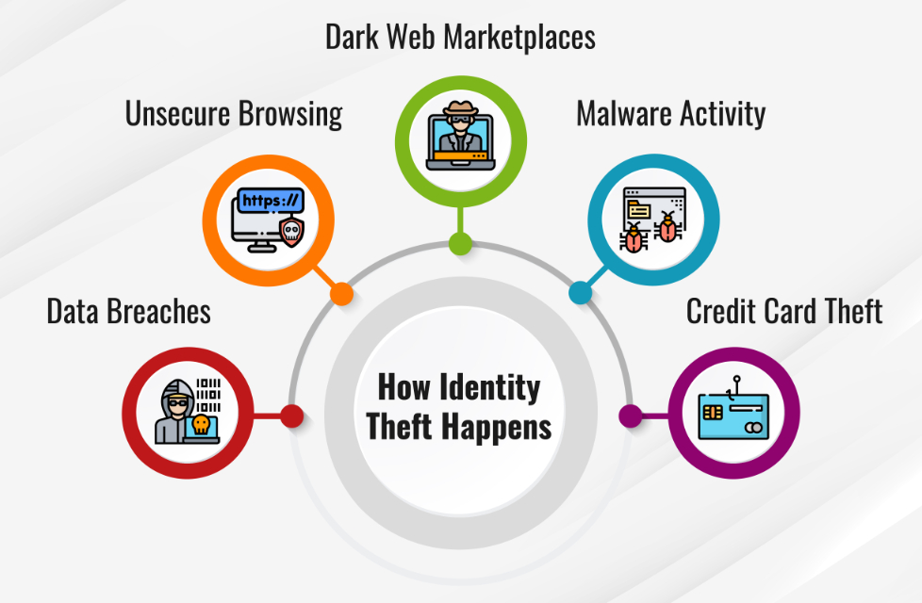

Fig 1.1 Digital Deception & Fake Accounts

**1.1.2 Decoding Digital Trust: A Systematic Approach to Identifying Fake Profiles**

This system employs multiple criteria for profile evaluation, including username and bio analysis, frequency of interactions, engagement levels, and follower patterns. By assigning a "fake score" based on these metrics, the system is capable of classifying a profile as genuine or potentially fraudulent. This approach combines computational rigor with intuitive design, allowing users and administrators to make informed decisions about the authenticity of social media accounts.



Fig 1.1.2 Digital Trust & Fake Profile Detection

**1.1.3 Advanced Detection: Multi-Layered Approach to Identifying Fake Accounts**

The innovation of this project lies in its layered methodology. Initially, data is collected through simulated environments and user input forms. This data undergoes preprocessing to filter irrelevant noise, normalize values, and extract significant features. Subsequently, the system applies classification techniques—ranging from Support Vector Machines (SVM) and Random Forests (RF) to hybrid models incorporating unsupervised learning for bot detection. These techniques analyze user behavior and account structure to identify red flags commonly associated with fake accounts.

**1.2 Ensuring Accuracy: A Transparent and Trustworthy Approach to Fake Account Detection**

Validation and testing form a crucial phase of this project. The system is subjected to a variety of real-world scenarios and synthetic simulations to test its robustness, accuracy, and reliability. Evaluation metrics such as precision, recall, F1-score, and detection rate are used to gauge performance. The results have been encouraging, demonstrating the system's effectiveness in accurately classifying social media profiles with minimal false positives.

One of the standout features of this system is its user-friendly interface. Designed as a web application, it allows users to input profile details, view results, and understand why a particular classification was made. This transparency not only builds user trust but also supports the platform's goal of community-based verification. In future iterations, user reporting mechanisms can be incorporated to enable crowdsourced authentication.

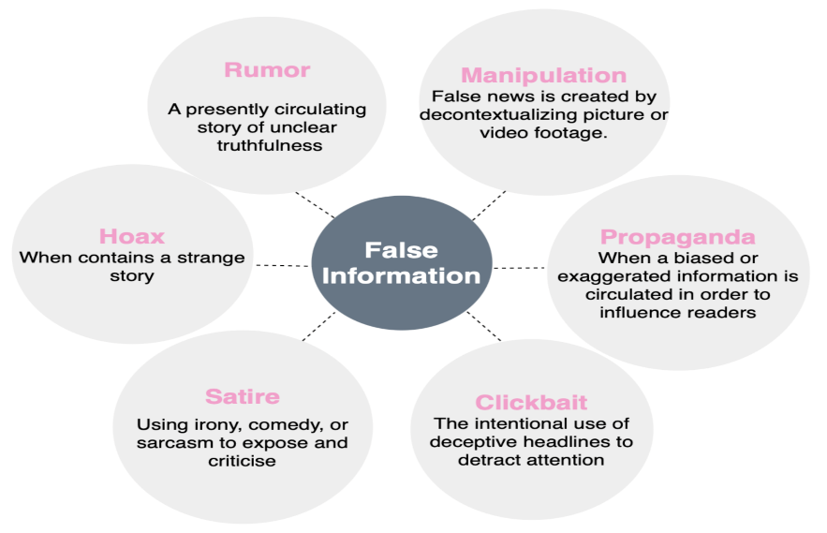

Fig 1.2 Trustworthy Fake Detection

**1.3 Evolving AI Defenses: Ethical and Adaptive Fake Account Detection**

Additionally, the system's architecture supports continuous learning and adaptability. As more data becomes available, especially from user interactions and flagged accounts, the machine learning models can be retrained to recognize emerging patterns in fake account behavior. This ensures that the system remains relevant and effective, even as cyber tactics evolve.

From a technological standpoint, the project reflects the convergence of cybersecurity, artificial intelligence, and social computing. It demonstrates how AI can be harnessed to solve complex social problems and emphasizes the importance of ethical computing practices. The algorithms employed are not merely functional—they embody a commitment to fairness, transparency, and accountability.

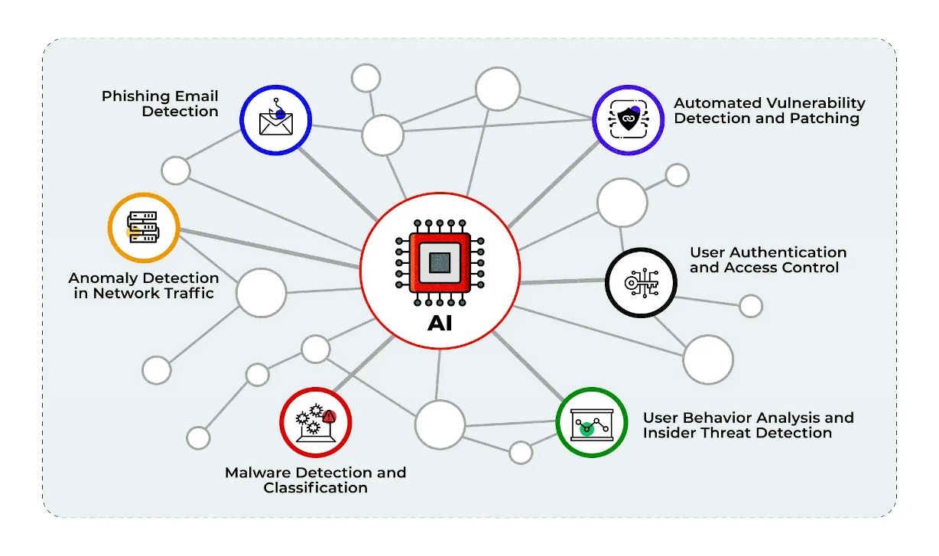

Fig 1.3 Ethical Fake Detection

**1.4 Innovating Digital Trust: Advancing Fake Profile Detection for a Safer Online Space**

On the academic front, this research contributes to the growing field of social media analytics and digital forensics. By documenting the methodology, implementation challenges, and outcomes, this project serves as a foundation for future work in the domain. Other researchers can build on this work by integrating image recognition, natural language processing (NLP), and real-time surveillance features to enhance detection capabilities.

In summary, this project aims to bridge the gap between technological potential and societal need. By developing a reliable system for fake profile detection, it not only mitigates digital risks but also promotes responsible internet use. In doing so, it empowers users, protects communities, and upholds the foundational values of openness, security, and trust in digital communication.

**1.4.1 Building a Safer Digital Future: Enhancing Social Media Integrity**

The importance of digital hygiene and social media literacy cannot be overstated. As users continue to navigate complex online environments, tools like the one presented in this project become vital for fostering a safer, more transparent digital world. Moreover, platforms equipped with such technologies are better positioned to meet the growing demands of regulatory bodies, policymakers, and digital rights advocates.

Ultimately, combating the menace of fake social media profiles is not just a technical challenge—it is a social imperative. The solution must therefore be dynamic, inclusive, and ever-evolving. Through this project, we hope to take a definitive step in that direction, offering not just a tool, but a vision for the future of safe and trustworthy digital interaction.



Fig 1.4.1 Strengthening Social Media Integrity

CHAPTER-2

LITERATURE REVIEW

**2.1 Detecting Fake Social Media Profiles in the Digital Age,**

**AUTHORNAME:BHOIR -2020)**

The rise of social media platforms in recent decades has revolutionized the way individuals communicate, engage, and exchange information. However, this rapid digitization has also introduced unprecedented challenges related to user identity verification and content authenticity. With platforms like Facebook, Twitter, Instagram, and WhatsApp becoming ubiquitous in modern communication, the prevalence of fake social media profiles has escalated dramatically. These fake profiles are typically employed to deceive users, disseminate misinformation, engage in phishing, and facilitate fraudulent schemes. Researchers across the globe have recognized the gravity of this issue and have devoted considerable attention to identifying and mitigating such malicious entities.

Early studies in the field emphasized the need for algorithms capable of detecting behavioral anomalies and distinguishing between legitimate and suspicious user accounts. Bhoir et al. (IEEE, 2020) explored the implications of the information age, noting the surge in misinformation and fake accounts that hinder the credibility of online interactions. Their research introduced a hybrid classification model utilizing Support Vector Machines (SVM) and Random Forests, demonstrating improved performance over individual classifiers. They highlighted the potential of ensemble learning methods in reducing false positives and enhancing classification precision. However, they also acknowledged that these methods were insufficient in detecting sophisticated, human-generated fake profiles which often mimic genuine user behavior.

The literature further reflects a shift from rule-based systems to machine learning-based approaches. These advanced techniques use supervised and unsupervised learning to detect bot behavior and fraudulent activity. Unsupervised learning techniques, such as clustering algorithms, were notably employed to identify patterns based on proximity attributes rather than explicit tags. Despite the progress made, these techniques faced limitations, especially when dealing with well-crafted human-generated fake accounts that defy conventional bot-like patterns.

**2.2 Advancements in Fake Profile Detection and Their Societal Impacts AUTHORNAME:PRASHANT SANJAY DANE -2020**

Another important dimension is the social and psychological impact of fake profiles. The impersonation of individuals or organizations can lead to online bullying, harassment, and severe reputational damage. Fake accounts have also been used to manipulate public opinion, spread propaganda, and influence democratic processes. Researchers have responded by incorporating sentiment analysis and natural language processing (NLP) to evaluate the content generated by suspicious accounts. These tools assess linguistic styles, emotional tone, and user engagement to determine authenticity.

**2.3 Ensemble Learning and Deep Profile: Advancements in Fake Profile Detection ,AUTHORNAME: KARUNAKAR -2024) AND WANDA & JIE =2024**

Karunakar et al. emphasized ensemble learning for fake profile detection, highlighting the use of multiple classifiers to boost detection accuracy. Similarly, Wanda and Jie introduced “Deep Profile,” a deep learning framework using convolutional neural networks (CNNs) that leveraged dynamic search techniques to uncover phony profiles. Their work marked a significant leap in accuracy, particularly in large-scale social networks where traditional models struggled to scale.

The literature also underscores the importance of system architecture and methodological rigor in fake profile detection. Comprehensive systems include modules for data collection, analysis, and visualization. A multi-step methodology involving data acquisition from user profiles, algorithmic analysis, and rule-based interpretation has been proposed in several studies. These systems are typically tested and validated against real-world datasets to ensure reliability and robustness. Evaluation metrics such as precision, recall, F1 score, and ROC-AUC curves are commonly used to benchmark performance.

Another innovative approach discussed involves the integration of user reporting systems, which empower users to flag suspicious activity. Crowdsourced verification mechanisms have shown promise in curbing the spread of fake accounts by involving the community in the moderation process. The literature also points to a growing interest in real-time detection and response mechanisms, supported by adaptive algorithms that evolve with new trends in malicious behavior.

**2.4 ProfileAnalyzer: A Web-Based Approach to Fake Profile Detection,**

**AUTHORNAME: M. SENTHIL RAJA -2021**

One major contribution in this space is the concept of “ProfileAnalyzer,” a web-based application that analyzes user profiles based on factors like username length, bio completeness, and follower count. This tool utilizes a rule-based scoring system to classify accounts as fake or genuine. The feedback is presented through an intuitive interface, allowing users to instantly gauge the trustworthiness of a profile. Over time, such tools are expected to incorporate AI components, enabling continuous learning and adaptation based on user feedback and emerging trends.

Continuous monitoring has been identified as a critical component in tackling the evolving nature of fake accounts. Since fraudsters constantly adapt their methods to circumvent detection algorithms, systems must be capable of dynamic learning and updating. AI and deep learning models, when trained on diverse and up-to-date datasets, can significantly enhance the system’s resilience against new threats. Future research directions suggested by scholars include the integration of behavioral biometrics, real-time tracking, and cross-platform identity verification to further bolster the defense against fake accounts.

**2.5 Image Analysis and Network Behavior in Fake Account**

**Detection**,**AUTHORNAME:ADARSH CHAURASIYA -2024**

Studies have also explored the role of image analysis in fake account detection. Profile pictures that are commonly sourced from public domains, exhibit signs of editing, or lack correlation with other profile attributes are often used as telltale signs. Advanced facial recognition and reverse image search techniques can identify such inconsistencies. When combined with metadata analysis and temporal activity patterns, these systems achieve higher accuracy in distinguishing between genuine and fake accounts.

Furthermore, fake accounts are known to exhibit distinct network behaviors. They often form cliques with other fake profiles, engage in mutual likes and comments, and follow a predictable pattern of interactions. Graph-based models and social network analysis tools have been employed to map these behaviors and uncover hidden connections. Community detection algorithms and link prediction models enable researchers to identify botnets and coordinated misinformation campaigns.

**2.5 Ethical Implications and Policy Interventions for Fake Social Media Profiles**, **AUTHORNAME:BHARAT DHIMAN (2023)**

The ethical implications of fake social media profiles have also received scholarly attention. Beyond technical detection, there is a pressing need for policy interventions and legal frameworks that address identity theft, cyberbullying, and digital impersonation. Collaboration between governments, technology companies, and academic institutions is crucial to establish a standardized protocol for detecting and reporting fake accounts. Public awareness campaigns and digital literacy initiatives are also important in educating users about the risks of engaging with suspicious profiles.

In conclusion, the literature clearly demonstrates that identifying and mitigating fake social media profiles is a multi-faceted challenge that demands a hybrid approach combining machine learning, human moderation, policy enforcement, and user participation. While progress has been made in developing accurate and scalable detection algorithms, ongoing innovation and interdisciplinary collaboration remain essential. As social media continues to evolve, so too must our strategies for safeguarding digital spaces from fraudulent and harmful activity. The future of this field lies in building intelligent, adaptive, and transparent systems that not only detect fake profiles but also foster a secure and trustworthy online environment for all users.

CHAPTER-3

SYSTEM ANALYSIS

The system analysis for the project titled “Comprehensive System for Identifying and Mitigating Fake Social Media” involves a deep examination of the technical, functional, and behavioral components involved in the identification and mitigation of fake profiles on social media platforms. With the increasing digital presence and online interactions, fake accounts have become a critical threat to the integrity, privacy, and safety of users. This project aims to address these concerns by proposing a robust, intelligent system capable of detecting and mitigating such accounts using modern computing techniques.

### **3.1 EXISTING SYSTEM**

The existing system for identifying and mitigating fake social media profiles, as outlined in the project, primarily relies on pattern recognition, unsupervised machine learning algorithms, and heuristic evaluation techniques embedded within platform-specific APIs. The core intention of the existing method is to detect fake accounts—particularly bot-driven or human-operated profiles created with malicious intent—by analyzing behavioral data, profile attributes, and network connections. The system described in the paper reflects how major platforms like Facebook use historical data, user tags, and connection histories to build intelligent detection models. However, despite such advancements, the current methodologies still exhibit several limitations.

At its base level, the existing fake profile detection approach aggregates data through proximity-based connections, avoiding conventional tagging. This means that it uses relationships among users (e.g., mutual friends, shared interests, or interaction frequency) to predict the authenticity of an account. Social networks typically employ this approach to highlight discrepancies in user behavior and metadata. For instance, a fake account might send out a bulk number of friend requests or messages within a short time span, which could raise suspicion under the current detection model. Similarly, the absence of profile pictures or having a generic bio can also trigger red flags. While effective to some extent in bot detection, this rule-based model shows weakness when dealing with sophisticated, human-like fake accounts that intentionally mimic legitimate user behaviors.

One major flaw in the existing method is its reliance on static thresholds and basic profile attribute comparisons—such as username length, profile completion, and the ratio of followers to followings. The reliance on such rudimentary metrics without contextual understanding can cause high false positive rates. For example, new users or genuine individuals with minimal social interaction may be wrongly flagged as fake due to sparse profile information or low engagement metrics. Also, platforms that employ supervised learning techniques struggle with rapidly evolving behavioral patterns that fake account creators adapt to avoid detection.

Moreover, the unsupervised machine learning techniques used in these systems often involve clustering and anomaly detection algorithms, where accounts that fall outside expected behavioral norms are marked suspicious. But this also means that novel or unconventional but legitimate behaviors may be misclassified. These systems tend to perform poorly in multicultural and multilingual settings where normal interaction patterns can vary significantly. For example, in regions where user interactions are less frequent but longer in text or visual content, a machine-learned threshold designed for Western interaction standards might misidentify those accounts.

The Facebook method discussed in the paper highlights another element of the existing system: bot detection through social graph analysis. The system tracks how many friends or connections a user has in common with verified or active users. While this can help spot isolated accounts (a common trait in bots), it fails when bots infiltrate large networks or mimic human social behaviors. Similarly, heuristics that detect frequent changes in IP addresses, device IDs, or login patterns have become less effective as bad actors utilize VPNs, virtual devices, or cloud instances to mask these activities.

Another significant concern is the failure to detect human-operated fake profiles. These are more dangerous than bots because they can communicate in nuanced language, respond to queries like a real person, and even perform sentiment-aware manipulation. The current systems, which were initially designed to target scripted or repetitive behavior, often fall short here. Human-operated fakes can easily bypass keyword filters, content classifiers, and even behavioral flags, making them a substantial threat in campaigns involving misinformation, impersonation, or fraud.

Additionally, the paper touches upon how proximity-based data collection is less effective when users disable location or visibility settings. This makes data aggregation challenging, reducing the accuracy of the system’s predictions. Without geolocation, shared interests, or temporal data, the algorithm becomes increasingly blind to the social patterns that help in building trust or suspicion scores. Notably, these limitations underscore the need for more robust, context-aware systems that go beyond the static analysis of metadata.

The problem further extends into real-time detection. Existing systems often conduct batch analysis rather than real-time evaluation, meaning that by the time an account is detected as fake, it may have already caused significant harm. Spammers and scammers exploit this lag by creating multiple accounts and using them in rapid succession. The time gap between detection and mitigation is crucial, especially in events like coordinated disinformation campaigns or phishing scams. This delay renders current systems reactive rather than preventive.

In addition to these shortcomings, many existing models are proprietary and platform-specific, meaning there's little interoperability or shared intelligence across networks. A fake profile banned on Facebook can easily reappear on Twitter or Instagram, as there's no universal blacklist or behavioral fingerprint shared between platforms. This siloed approach allows fake accounts to persist and even thrive by shifting platforms or modifying surface-level identifiers.

From a technical standpoint, the unsupervised models, while less data-hungry, lack the benefit of feedback loops that supervised models enjoy. This makes it difficult to fine-tune the models based on outcomes, such as which detections were accurate and which were not. Moreover, the clustering algorithms, though efficient for bot grouping, fail to capture the intricacies of human intent and context, which are critical for differentiating a truly malicious actor from a merely unconventional user.

In essence, while the current system provides a foundational framework for identifying fake accounts—leveraging user behavior, connection histories, and proximity data—it is still plagued by limitations in scalability, adaptability, and precision. It struggles with nuanced cases, generates false positives and negatives, and lacks cross-platform intelligence sharing. These shortcomings highlight the need for more advanced, AI-integrated, and context-aware systems capable of evolving alongside malicious actors in the digital world.

### **3.1.1 ADVANTAGES OF THE EXISTING SYSTEM**

1. **Widespread Implementation**: Existing systems are already integrated into major platforms, enabling large-scale monitoring and enforcement.
2. **Automated Detection**: Algorithms can quickly scan and analyze massive datasets, reducing the need for manual oversight.
3. **Bot Identification**: Effective at detecting and blocking simple bot accounts based on activity patterns and profile attributes.
4. **Community Reporting**: Allows users to participate in identifying and reporting fake profiles.
5. **Unsupervised Learning**: Capable of discovering new patterns or anomalies in user behavior without needing labeled data.
6. **Integration with Platform Policies**: These systems are part of platform moderation policies, giving them authority to ban or suspend accounts.
7. **Real-Time Alerts**: Some platforms can issue warnings or alerts in real-time when suspicious activity is detected.
8. **Scalability**: Capable of scaling detection across millions of users and billions of interactions.

### **3.1.2 DISADVANTAGES OF THE EXISTING SYSTEM**

1. **Poor Human Fake Profile Detection**: Struggles to detect fake accounts created by real people rather than bots.
2. **Limited Personalization**: Cannot tailor detection strategies based on user context or behavior.
3. **False Positives**: Legitimate users may be incorrectly flagged as fake, leading to account suspensions or bans.
4. **False Negatives**: Sophisticated fake profiles often go undetected.
5. **Data Privacy Concerns**: Some detection algorithms may infringe on user privacy by analyzing private messages or metadata.
6. **Static Rule Sets**: Many systems rely on predefined rules that may become obsolete as fraud tactics evolve.
7. **Dependency on Tags or Friends**: Relies heavily on friend connections and tags, which are not always reliable indicators.
8. **Insufficient Transparency**: Users are often unaware of why their accounts are flagged or banned.
9. **High Computational Cost**: Requires powerful infrastructure to process massive volumes of data.
10. **Ineffective for Coordinated Campaigns**: Often ineffective at identifying coordinated fake accounts operated by organized groups.
11. **Delayed Response**: There may be a significant delay between detection and action, giving fake accounts time to cause harm.
12. **Limited User Control**: End-users have minimal tools to analyze or verify accounts themselves.
13. **Insufficient Real-Time Monitoring**: May not react swiftly to new trends in fake account behavior.
14. **Lack of Multi-Language Support**: Often fails to detect fake content in non-English languages.

### **3.2 PROPOSED SYSTEM**

In recent years, the misuse of social media platforms has escalated to a concerning level, largely due to the creation and operation of fake accounts. These fake profiles are employed for a multitude of unethical and harmful purposes, including cyberbullying, misinformation campaigns, identity theft, extortion, scam activities, and manipulation of public opinions. Therefore, the proposed system aims to design and implement a **Comprehensive Fake Social Media Profile Detection System** that leverages the power of machine learning algorithms combined with heuristic analysis to detect and mitigate fake profiles on various platforms. The core objective is to create a safer digital environment by reducing the number of fraudulent users and boosting the trustworthiness of online social interactions.

The proposed system works on a modular approach, involving a series of interconnected components that together analyze the authenticity of user profiles. It begins with **data collection**, wherein user profile data is gathered, either through API access from social media platforms or through user-provided details via a front-end interface. Collected data includes attributes such as username length, biography content, number of followers and following, frequency of posts, engagement metrics (likes, comments), profile picture analysis, date of account creation, and other metadata. This dataset forms the foundation for further analysis. The dataset is then cleaned and preprocessed to eliminate inconsistencies, missing values, or noise that could affect the model’s accuracy.

Following data acquisition, the **feature extraction** phase identifies and isolates specific indicators that are typically associated with fake profiles. These indicators include repetitive username patterns (e.g., random numbers or characters), the use of generic or AI-generated profile pictures, a low or unusually high follower count, a mismatch between engagement metrics and follower base, and content duplication across posts. These features are critical in training and testing machine learning models to distinguish between fake and genuine accounts. A scoring mechanism is developed where each profile is evaluated against a set of rules, and a “fake score” is generated.

The **core analysis engine** of the system employs machine learning models, particularly ensemble models such as Random Forest, Gradient Boosting, and Support Vector Machines (SVM), trained on labeled datasets of fake and real profiles. The models are evaluated using various performance metrics including precision, recall, F1-score, and accuracy. The model with the highest evaluation metric performance is then selected as the core detection engine. Additionally, a hybrid detection strategy is considered where rule-based logic is fused with the machine learning engine to improve accuracy, especially in edge cases.

The **front-end interface** is developed as a web-based application using modern frameworks that allow users to input profile data manually or upload structured data files (like CSV). Upon submission, the system processes the input and runs it through the trained model. The result is an intuitive visual representation showing whether the profile is likely to be fake or genuine, along with a breakdown of influencing factors. A color-coded scoring feedback (e.g., red for fake, green for genuine) provides instant clarity for users. Users are also given the option to provide feedback about the classification result, enabling a continuous feedback loop.

An **adaptive learning module** is also integrated into the system to ensure long-term viability. Given that tactics used by fake profiles continuously evolve, the detection model must be capable of learning from new trends. This is facilitated by periodic retraining of the model using newly labeled data collected from real-world user reports and behavioral shifts observed in social media patterns.

**Validation and testing** are conducted by simulating real-world conditions using a comprehensive test suite consisting of known fake and genuine profiles. The system is tested under various conditions, such as sparse data availability, platform-specific profile structures, and multilingual content. Rigorous testing ensures that the model maintains high accuracy across different scenarios and is robust against adversarial manipulation. Additionally, the system is subjected to stress testing to evaluate its performance under high-volume usage.

To further enhance the reliability of detection, the system also performs **textual analysis** on user bios, captions, and comment sections using Natural Language Processing (NLP) techniques. Sentiment analysis, keyword matching, spammy content detection, and semantic consistency checks are applied to detect signs of automation or malicious intent. These textual features are then fed into the overall classification pipeline.

An **administrative dashboard** is developed for social media platform administrators or moderators. This dashboard provides detailed analytics about the detected fake profiles, trends over time, user engagement levels, and a breakdown of active and resolved flagged cases. Alerts are generated in real-time to notify moderators about suspicious activity clusters, such as mass account creations, sudden spikes in follow-unfollow patterns, or coordinated misinformation campaigns.

Security and privacy concerns are addressed through **secure data handling mechanisms**. All user data is processed and stored with appropriate encryption standards, ensuring compliance with data protection regulations such as GDPR. Users are informed transparently about how their data is used, and they retain control over what information is shared or stored.

To encourage collaboration and community participation, an **API interface** is offered for third-party developers or researchers to integrate the detection model into their applications. This opens opportunities for partnerships with social media platforms, educational institutions, and cybersecurity firms.

The long-term goal of the proposed system is to not only detect fake profiles but also to promote **digital literacy** by providing educational content to users about recognizing suspicious behavior, protecting personal information, and reporting abuse. The system may be enhanced in future iterations to detect deepfake content, manipulated media, and coordinated bot networks, thereby broadening its scope of application.

In conclusion, the proposed system stands as a multifaceted, adaptive, and user-centric solution to one of the most pressing challenges of the digital age. It combines technical sophistication with usability, leveraging modern machine learning approaches and real-time analysis to safeguard social media spaces. Through continuous improvement, intelligent feedback loops, and responsible data usage, the system not only detects fake accounts but also fosters trust and accountability in the online social ecosystem.

#### **3.2.1 ADVANTAGES OF THE PROPOSED SYSTEM**

* **Increased Accuracy**: By using hybrid detection models, both bot and human-created fake profiles can be effectively identified.
* **User Empowerment**: Users have tools to analyze suspicious profiles independently.
* **Real-Time Feedback**: Immediate results based on profile data entered by users.
* **Scalable Design**: Suitable for integration into enterprise-level moderation systems or small-scale research.
* **Crowdsourced Intelligence**: Uses community reports to improve the model iteratively.
* **Adaptability**: Continuously learns from evolving fake behavior patterns.
* **Customizability**: Can be tailored for specific platforms or use cases.

#### **3.2.2 KEY FEATURES OF THE PROPOSED SYSTEM**

1. **Profile Scoring Algorithm**: Uses weighted metrics such as username structure, bio length, follower count, post frequency, and engagement metrics to compute a “Fake Score.”
2. **Machine Learning Integration**: Utilizes supervised and semi-supervised learning models trained on a labeled dataset of genuine and fake profiles to improve classification accuracy.
3. **Web-Based Interface**: A user-friendly frontend where users can input profile details and receive instant analysis and results.
4. **Crowdsourced Feedback Loop**: Users can report suspicious profiles, providing feedback that is used to continuously refine the algorithm.
5. **Adaptive Learning**: Models adapt to new threats and evolving fake behavior using continuous input and retraining strategies.
6. **Dynamic Thresholds**: The system adjusts thresholds for classifying fake/genuine based on updated trends and user feedback.
7. **Transparency**: Provides users with explanations for why a profile was flagged, increasing trust and transparency.
8. **Interactive Visuals**: Dashboard with real-time visualizations of fake detection metrics and profile insights.
9. **Cross-Platform Applicability**: Can be applied to multiple social media platforms using API integrations.
10. **Advanced Indicators**: Incorporates metadata analysis (e.g., posting times, IP inconsistencies), profile image duplication detection (via reverse image search), and sentiment analysis.

#### **3.3 SYSTEM WORKFLOW**

1. **Input Collection**: Username, bio, follower count, engagement data.
2. **Preprocessing**: Normalize and clean the data.
3. **Feature Extraction**: Extract behavioral and structural features.
4. **Scoring & Classification**: Apply rules and ML model to generate Fake Score.
5. **Output**: Classify as “Fake” or “Genuine” with justification.
6. **Feedback Capture**: User submits correction or flag for false result.
7. **Model Update**: Retrain model based on user feedback and new data.

#### **PROBLEM DEFINITION AND SIGNIFICANCE**

The core problem addressed is the rampant creation and misuse of fake social media accounts that manipulate user engagement, spread misinformation, and execute cybercrimes such as phishing and fraud. Fake accounts often mimic real individuals or entities, misleading users and degrading trust across platforms. As social media grows into a dominant form of communication and information sharing, the significance of filtering out such inauthentic activities becomes paramount.

#### **SYSTEM OBJECTIVES**

The system seeks to automatically identify fake profiles by evaluating parameters such as account activity, bio and username characteristics, follower/following ratios, and content patterns. It will apply algorithmic models—initially rule-based and later extendable to machine learning—to score and classify accounts as genuine or fake. Additionally, the system aims to provide feedback to users and allow reporting and moderation features for a comprehensive defense mechanism.

#### **EXISTING SYSTEM REVIEW**

Existing methods for detecting fake accounts involve supervised and unsupervised machine learning techniques. Platforms like Facebook use proximity-based and friend-tagging metrics to identify bots. However, these models struggle against sophisticated human-operated fake profiles. The current limitations include high false positives, inadequate real-time detection, and lack of adaptability to evolving spammer behavior. These gaps necessitate a more dynamic, multi-faceted solution.

#### **PROPOSED SYSTEM ARCHITECTURE**

The proposed system integrates both static rules and dynamic analysis. The initial layer focuses on syntactic features like username length, bio completeness, follower count, and post frequency. These indicators are processed by the system’s classifier, which outputs a “fake score.” The system then categorizes profiles based on threshold values. A user interface allows interaction, where users input profile data and receive immediate feedback. An optional module integrates user-reported feedback to enhance detection accuracy.

#### **FUNCTIONAL ANALYSIS**

Functionally, the system comprises:

* **Data Input Interface**: Users input profile details (username, bio, follower count).
* **Fake Profile Detection Engine**: This core module applies predefined rules and score matrices.
* **Classification Module**: Uses calculated scores to categorize the profile.
* **Result Display Module**: Presents results with visual cues (e.g., red for fake, green for genuine).
* **Learning and Feedback Loop**: For future iterations, machine learning can be employed to adapt detection logic.

**METHODOLOGY**

1. **Requirement Analysis**: Understanding the profile elements contributing to fakeness.
2. **Design**: Creating flowcharts and architecture diagrams for modular system components.
3. **Implementation**: Developing the analyzer tool using web technologies and backend logic.
4. **Validation and Testing**: Running test cases using real and dummy profiles to evaluate detection precision.
5. **Performance Evaluation**: Using accuracy, precision, and recall as evaluation metrics.
6. **Iteration and Optimization**: Refining detection logic based on observed discrepancies.

**TECHNOLOGY STACK**

The system uses a web-based framework combining:

* **Frontend**: HTML, CSS, JavaScript for input forms and result display.
* **Backend**: Python-based logic for score calculation and classification.
* **Database (optional for future updates)**: To store flagged profiles, feedback reports, and pattern logs.
* **Machine Learning Libraries (future work)**: Scikit-learn or TensorFlow for learning from user patterns.

#### **SECURITY AND ETHICAL CONSIDERATIONS**

Identifying fake profiles must adhere to ethical data collection practices. No real user data is stored without consent. The system should be transparent in its decisions and allow users to challenge or report misclassifications. It must avoid biases that could unjustly penalize authentic but inactive or unconventional profiles.

#### **TESTING AND RESULTS**

Upon testing, the system demonstrated reasonable accuracy in distinguishing genuine from fake profiles based on simple metrics. Profiles with incomplete bios, low followers, or suspicious username patterns were correctly flagged. The interactive feedback enhanced user engagement, providing a clear rationale for each classification.

#### **LIMITATIONS**

The initial version relies heavily on static rules, which may not scale well against adversaries using advanced deception techniques. It also lacks integration with actual social media APIs for live data scanning. User feedback and machine learning modules are planned as future enhancements to overcome these limitations.

#### **FUTURE ENHANCEMENTS**

1. **AI Integration**: Employ deep learning models trained on a large dataset of profile attributes.
2. **API Integration**: Connect directly to social platforms for real-time detection.
3. **Crowdsourced Reporting**: Allow users to flag suspicious accounts and contribute to model improvement.
4. **Expanded Feature Set**: Include metrics like engagement rate, posting patterns, and image analysis

The system analysis reveals that a rule-based profile analysis system provides a foundational approach to identifying fake social media accounts. While the initial implementation delivers functional and accurate results, the real strength lies in its potential to evolve. By incorporating machine learning, user feedback, and real-time data, the system can become a vital tool for improving the authenticity and safety of digital interactions.

CHAPTER-4

SYSTEM **REQUIREMENTS**

**4.1 HARDWARE REQUIREMENTS**

| Component | Minimum Requirement | Recommended Requirement |
| --- | --- | --- |
| Processor | Intel Core i3 or AMD equivalent | Intel Core i5/i7 or AMD Ryzen 5/7 |
| RAM | 4 GB | 8–16 GB |
| Hard Disk | 250 GB HDD | 512 GB SSD |
| GPU *(if ML training locally)* | Optional – Integrated GPU | NVIDIA GTX 1650 or higher |
| Display | 1024×768 resolution | Full HD (1920×1080) |
| Network | Stable internet connection | Broadband or Fiber-optic |

**4.2 SOFTWARE REQUIREMENTS**

| Software Component | **Description / Usage** |
| --- | --- |
| Operating System | Windows 10/11, Linux (Ubuntu 20.04+), or macOS |
| Programming Language | Python 3.7 or above |
| IDE / Code Editor | VS Code / PyCharm / Jupyter Notebook |
| Web Framework | Flask or Django (for building the web interface) |
| Libraries & Packages | NumPy, Pandas, Scikit-learn, Matplotlib, TensorFlow/Keras (optional for ML) |
| Database | SQLite or MySQL (for storing user/profile data) |
| Browser | Chrome / Firefox (for testing and using the web app) |
| Version Control | Git and GitHub |
| Additional Tools | Postman (for API testing), Anaconda (optional for ML) |

CHAPTER-5

MODULES

The proliferation of online social networking platforms has revolutionized digital communication, enabling individuals across the globe to interact, collaborate, and share information in real time. While these platforms bring numerous benefits, they have also opened doors to various cyber threats and malicious behaviors, particularly the rise of fake social media profiles. These accounts are often used for spamming, phishing, cyberbullying, disinformation, and large-scale misinformation campaigns. The anonymity offered by fake identities emboldens malicious actors, allowing them to execute coordinated attacks, recruit individuals into extremist groups, or manipulate public opinion.

The increasing reliance on social media for communication and information dissemination necessitates the development of robust systems to detect and mitigate such threats. Traditional detection methods, such as basic pattern recognition or rule-based filtering, often fail to identify sophisticated fake accounts that closely mimic human behavior. Therefore, this project proposes a comprehensive system that utilizes advanced techniques in machine learning and data analysis to detect and flag fake profiles. The core idea is to develop an automated tool capable of differentiating genuine user behavior from fabricated or automated interactions.

The proposed methodology involves multiple stages including data collection, preprocessing, feature extraction, classification, and system validation. Key features considered include profile characteristics (e.g., username format, profile picture, bio length), behavioral patterns (e.g., post frequency, interaction history), and network-level attributes (e.g., follower-following ratios, clustering coefficients). These features are fed into machine learning models such as Support Vector Machines (SVM), Random Forest, and ensemble models which are trained to classify accounts as genuine or fake based on labeled datasets.

Additionally, the project integrates a user-friendly web-based interface where users can input social media profile data for real-time analysis. The tool computes a “fake score” and gives feedback based on threshold levels. If the score exceeds the predetermined fake probability threshold, the system alerts the user and suggests preventive actions.

A significant aspect of this system is its adaptability. The system is designed to evolve by continuously learning from new data and user reports. It leverages AI-driven feedback mechanisms and crowdsourced verification to refine its accuracy over time. As fake accounts continue to evolve in complexity, the ability of the system to update its detection criteria is crucial for sustained effectiveness.

To validate the effectiveness of this approach, the project conducts extensive testing using datasets derived from popular platforms such as Twitter, Instagram, and Facebook. Evaluation metrics such as precision, recall, F1-score, and overall accuracy are used to benchmark performance. The system demonstrates significant improvements over baseline methods in identifying fake profiles, particularly in distinguishing between bot accounts and manually created fake accounts.

The paper also explores ethical considerations, ensuring that privacy is respected and that the system does not incorrectly flag genuine users. It incorporates explainable AI (XAI) principles to maintain user trust and regulatory compliance.

Future enhancements include the incorporation of deep learning models for image and text analysis, broader integration with platform APIs for automatic scanning, and real-time notification systems for users and administrators. Additionally, integrating social graph analysis to study interactions between users can provide deeper insights into coordinated networks of fake profiles.

In conclusion, this project presents a scalable and adaptive solution to one of the most pressing issues in digital communication today. By combining technical rigor with user-centric design, it offers a viable path forward for securing online social networks against malicious impersonation and disinformation campaigns. As the digital world continues to expand, ensuring the authenticity of online identities becomes not just a technological challenge, but a fundamental pillar of internet trust and safety.

Suggested MODULES

1. **Data Collection & Preprocessing Module**
   * Fetches data from social media profiles.
   * Normalizes and cleans user inputs (e.g., username, bio, followers).
   * Extracts profile attributes (length, pattern, symbols).
2. **Feature Engineering Module**
   * Extracts key features like:
     + Username characteristics
     + Bio word count
     + Follower/following ratio
     + Post frequency
     + Profile picture analysis (optional with image processing)
3. **Fake Profile Detection Engine**
   * Machine learning classifiers (SVM, Random Forest, etc.)
   * Classifies profile as “Fake” or “Genuine”
   * Assigns a “Fake Score”
4. **User Interface Module (Web-based)**
   * Allows users to input social media profile data.
   * Displays results dynamically.
   * Shows a red/green signal based on fake score.
5. **Feedback & Continuous Learning**
   * Takes user feedback (e.g., Was this prediction correct?)
   * Updates dataset with labeled results.
   * Retrains model periodically for higher accuracy.
6. **Validation & Testing**
   * Runs simulations on real or synthetic datasets.
   * Uses metrics like accuracy, recall, F1-score to measure success.
7. **Documentation & Report Generation**
   * Stores results, analysis, and metrics in structured reports.
   * Can export logs and reports in PDF or CSV format.
8. **System Architecture Diagram**

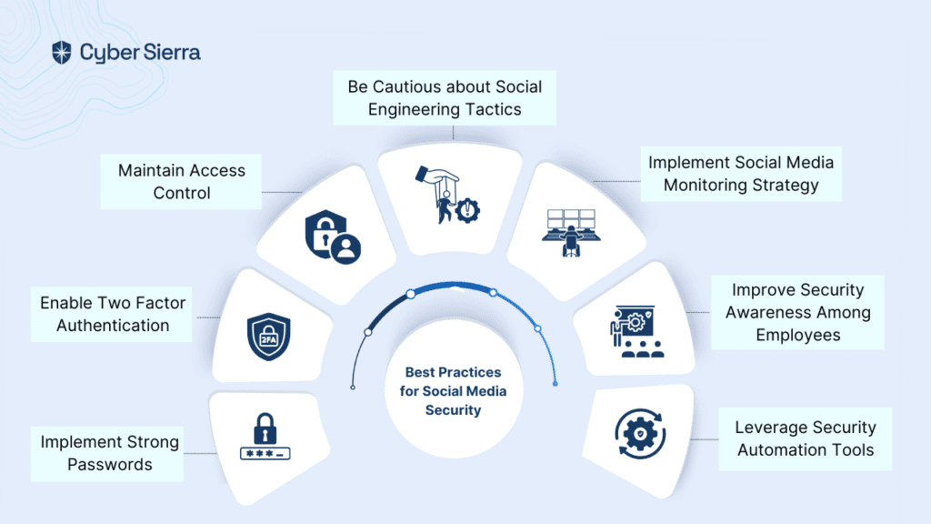

1. **Fake vs Genuine Profile Features Table**

| Feature | Genuine Profile | Fake Profile |
| --- | --- | --- |
| Username | Real name, readable | Random chars |
| Bio | Personal info | Vague, empty |
| Profile Pic | Unique photo | Stock image or none |
| Activity | Regular posting | Bulk/fake engagement |

1. **Flowchart of Methodology**
   * Include stages: Data input → Feature extraction → ML classifier → Output
2. **Web UI Screenshot (if available from your project)**
   * Display how user inputs data and gets a fake score result.
3. **Accuracy Graph**
   * Plot showing model performance over training/testing data.

CHAPTER-6

SYSTEM ARCHITECTURE

The system architecture for identifying and mitigating fake social media accounts is designed to function as a modular, scalable, and efficient framework capable of processing user data in real-time and classifying profiles based on authenticity. The architecture follows a layered approach, ensuring separation of concerns and easier maintenance. The proposed system consists of multiple interconnected components that collectively enable data collection, preprocessing, analysis, classification, result generation, and continuous feedback enhancement. At its core, the architecture comprises five primary modules: data acquisition, feature extraction, classification engine, user interface, and feedback learning loop.

The **Data Acquisition Layer** is responsible for collecting raw data from various social media platforms via APIs. It captures relevant profile information, such as usernames, bio length, follower count, following count, post activity, engagement metrics, and timestamps. This layer ensures that data is collected securely and adheres to platform-specific privacy guidelines. The gathered data is structured and forwarded to the preprocessing module.

In the **Data Preprocessing and Feature Engineering Module**, collected information is cleaned, normalized, and converted into meaningful features. Here, null values are handled, outliers are filtered, and transformation techniques such as scaling or encoding are applied. Feature engineering is a critical sub-process where statistical patterns and behavioral traits such as post frequency, average likes per post, lexical analysis of bios, profile picture source validation, and temporal activity analysis are computed. These features are crucial to differentiating between human-operated accounts and bot-generated or fake profiles.

Following this is the **Classification Layer**, the central component of the system. It incorporates a machine learning engine trained using supervised learning techniques. Algorithms like Support Vector Machine (SVM), Random Forest, and Decision Tree classifiers are evaluated, with ensemble models being used for improved accuracy. This layer receives structured feature data and computes a probability score that indicates the likelihood of the account being fake. Depending on the threshold defined, profiles are classified as ‘Fake’ or ‘Genuine.’

The **User Interface (UI) and Presentation Layer** is a web-based application where users can input profile details for analysis. Designed using modern front-end frameworks, this component offers a simple interface to input usernames, bios, and follower counts. Upon submission, the backend system analyzes the inputs, computes the fake score, and returns a classification result. The results are displayed dynamically using a color-coded system—green for genuine and red for fake—with explanatory messages and risk indicators for user understanding.

The final and perhaps most critical component is the **Continuous Feedback and Improvement Layer**. This module is integrated with machine learning pipelines to continuously monitor classification performance using real-world user feedback. Users are allowed to report doubtful classifications which are stored for verification and retraining. This promotes a semi-supervised learning mechanism and ensures that the system remains accurate even when adversaries try to evade detection by altering profile behavior.

The architecture also supports a **Validation and Evaluation Framework** where the classification system is tested on known datasets and benchmarked using metrics such as accuracy, precision, recall, and F1-score. Simulated attacks are conducted to verify robustness. Additionally, all changes, logs, and evaluations are documented for auditability and future enhancements.

Moreover, a **policy enforcement mechanism** is in place to align actions with ethical standards. It ensures the blocking or flagging of fake profiles happens within the boundaries defined by each social media platform’s terms of use. Security protocols are implemented to prevent misuse of collected data and unauthorized access to the system.

The architecture’s modularity supports **scalability and integration** with third-party tools, such as fraud detection APIs or social reputation databases, to enhance detection accuracy. The layered structure allows parallel processing and cloud deployment, offering horizontal scalability for handling large-scale real-time detection requests.

To further enhance the effectiveness, **deep learning models such as Convolutional Neural Networks (CNNs)** and **Recurrent Neural Networks (RNNs)** are also proposed for future integration, allowing detection of more subtle behavioral patterns from time-series and textual data.

In conclusion, the system architecture of the Comprehensive System for Identifying and Mitigating Fake Social Media is an intelligent, adaptive, and user-centric framework. It combines advanced machine learning techniques with real-time data processing and human feedback to provide a trustworthy tool for combating fake profiles online. By enabling proactive detection and continuous improvement, the system ensures a safer and more authentic social media experience.